**Task No. 1:** Practice all the Linux commands discussed in this lab while taking assistance using the man command. Write the complete syntax used for utilizing the cp, mv and rm commands in Linux shell.

**Solution:**

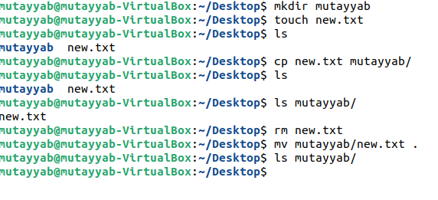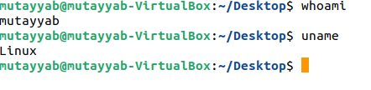

**Output:**

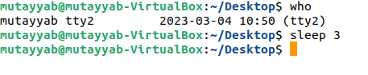

**Task No. 2:** Write the C programs to find the factorial of any number and generate their outputs over Linux environment.

**Solution:**

#include <stdio.h>

int main(){

int number,fact=1;

printf("Enter Any Number ");

scanf("%d",&number);

for(int i=1;i<=number;i++){

fact=fact*i;

}

printf("Ansers of %d is %d \n",number,fact);

return 0;

}

**Output:**

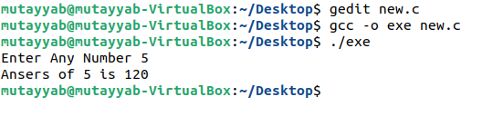

**Task No. 3:** Write a C program on the Linux environment that takes your marks as an input and display your grades accordingly to that followed at Bahria University. Limit your program to a maximum of five subjects. Use the suitable logical operator(s), i.e. and (&&), or (||), not (!), if required.

**Solution:**

#include <stdio.h>

int main(){

int subject;

double sum,percentage,marks;

printf("Enter Total number of Subjects ");

scanf("%d",&subject);

for(int i=1;i<=subject;i++){

printf("Enter Marks Of Subject %d :",i );

scanf("%lf",&marks);

sum+=marks;

}

percentage=(sum/850)*100;

if(percentage>80){

printf("Your Grade of %f is A \n",percentage );

}else if(percentage>70&&percentage<80){

printf("Your Grade of %f is B \n",percentage );

}else if(percentage>60&&percentage<70){

printf("Your Grade of %f is C \n",percentage );

}else if(percentage>50&&percentage<60){

printf("Your Grade of %f is D \n",percentage );

}

else if(percentage>40&&percentage<50){

printf("Your Grade of %f is E \n",percentage );

}

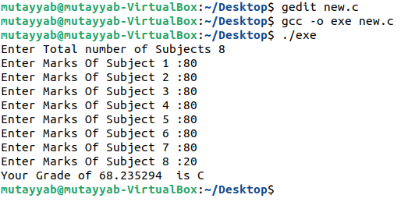return 0;

}

**Output:**

**Task No. 4:** Write a shell script to display your address over multiple lines.

**Solution:**

#!/bin/bash

echo "Enter Your Address "

read adddress

echo "your Address Is " $adddress

**Output:**

**Task No. 5:** Write a shell script that would traverse among any three directories that are placed under the /home directory. While moving from one directory to another, the script should display the name of the current working directory and list the content within that directory, including the hidden files.

**Solution:**

#!/bin/bash

cd A

pwd

ls -al

cd ..

pwd

cd B

pwd

ls -al

cd ..

pwd

cd C

pwd

ls -al

cd ..

pwd

**Output:**

